

[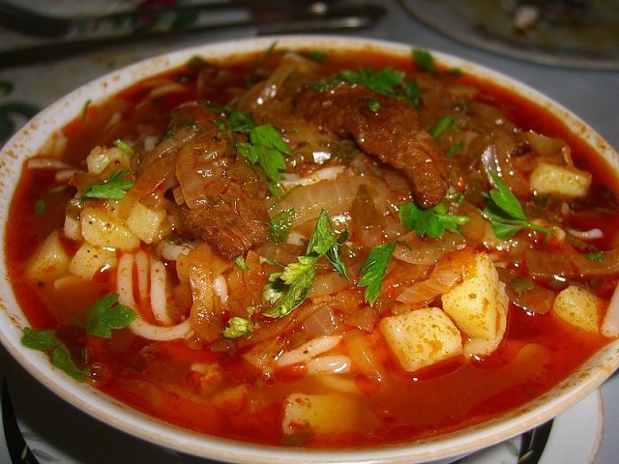](https://ok.ru/dk?cmd=PopLayerPhoto&st.layer.cmd=PopLayerPhotoOuter&st.layer.type=GROUP&st.layer.revNav=off&st.layer.limitedUi=true&st.layer.showNav=off&st.layer.photoAlbumId=52822372122868&st.layer.photoId=836627482100&st.layer.navStartPhotoId=836627482100&st.layer.sbd=off&st.cmd=userMain&st._aid=GroupTopicLayer_openPhotoLayer)